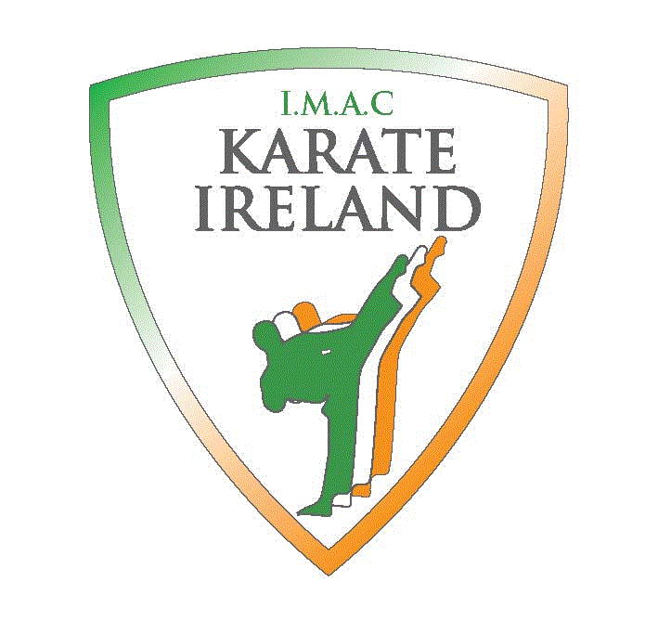
Karate Ireland

World Championships for All Ages

The Hub,
Kilkenny City
Co Kilkenny, Ireland

October 20-22nd 2017
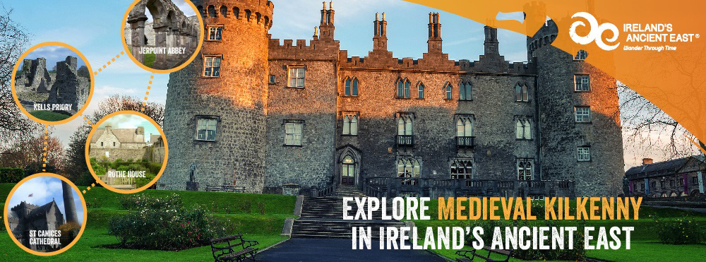

Kilkenny

Karate Ireland would like to host the World Championships and World Cup for children in
The Hub at Cillin Hill, the premier multi-purpose venue in the South East. Located in a commanding roadside position on the outskirts of thriving Kilkenny City, The Hub is located within Cillin Hill (visit www.cillinhill.com). The Hub is an ideal venue for the IKU world championships. There are many hotels within walking distance of the venue.

Once the medieval capital of Ireland, the city has a rich medieval heritage visible through its narrow streetscapes its historical buildings and landmarks, the city's origins predate existing medieval landmarks. Saint Canice (who gives Kilkenny its name) founded a monastic settlement here in the 6th century. The 9th century round tower beside the wonderful stone cathedral of St Canice’s, is a remaining monastic landmark. Built in the 13th century and a showcase to ornate stonemasonry skills, St Canice’s is the second longest Cathedral in Ireland.

Strongbow, the legendary Norman invader, built a fort in the 12th C on the site where Kilkenny Castle stands today. William Marshall (Strongbow's son-in-law, 4th Earl of Pembroke) fortified the city walls, built a stone castle on the site and consolidated the Norman's position of power in the city.

Kilkenny is also renowned as a world class craft centre, which has its origins in the Design workshops of the late 1960s’, the story of which can be explored in the Castle Yard site.
One of the best and unique features of Kilkenny is its compactness allowing you explore everything it has to offer on foot, just be sure to allow yourself enough time to experience it all. Enjoy our city!
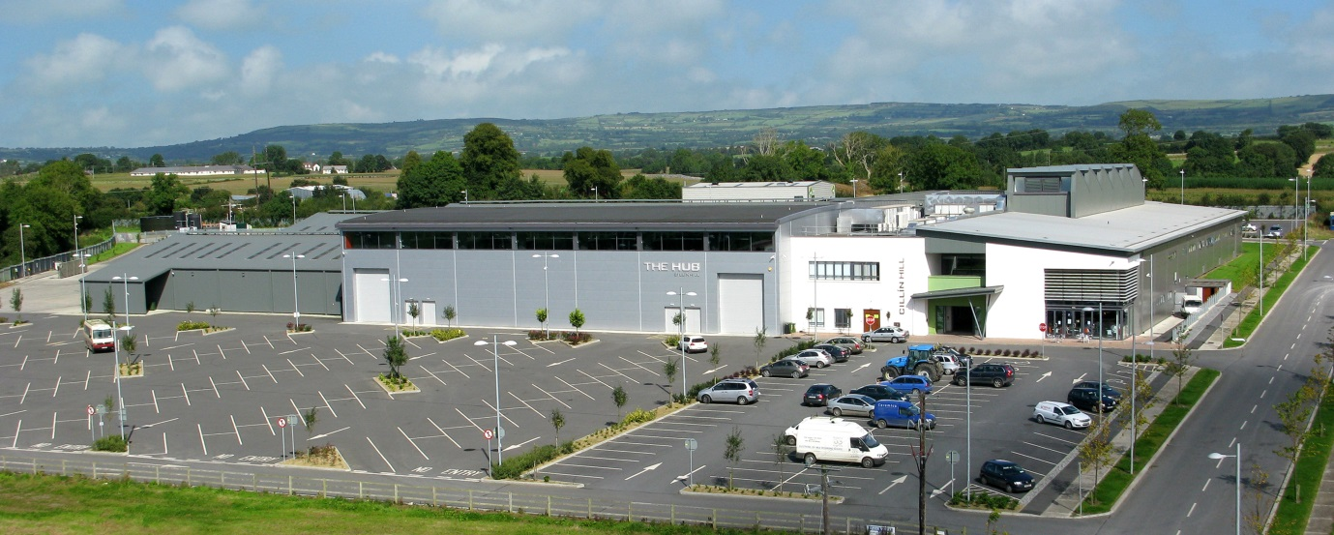

The Hub Venue

Dublin Airport is only 1 hour 24mins has flights to all major destinations.

Some of the Hotels in Kilkenny
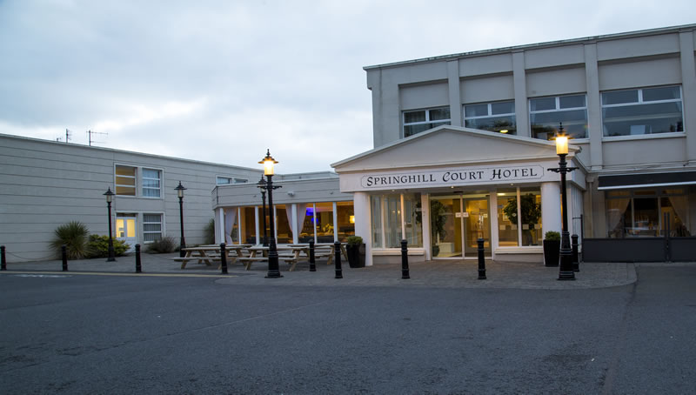
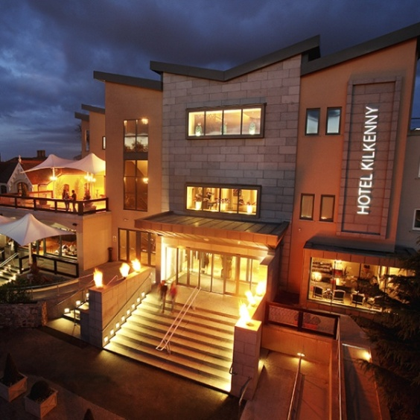
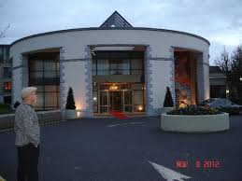
In the coming weeks there will be a website available which will have all the hotels, apartments & hostel available in the area, with transport from and to the airport and they will have special rates for all federations travelling to Kilkenny. They will also have visa information and day trips to the local and surrounding historical sites.
For information please contact by email : karate2017@keynotepco.ie
http://www.karate2017ireland.com
www.karateireland.org

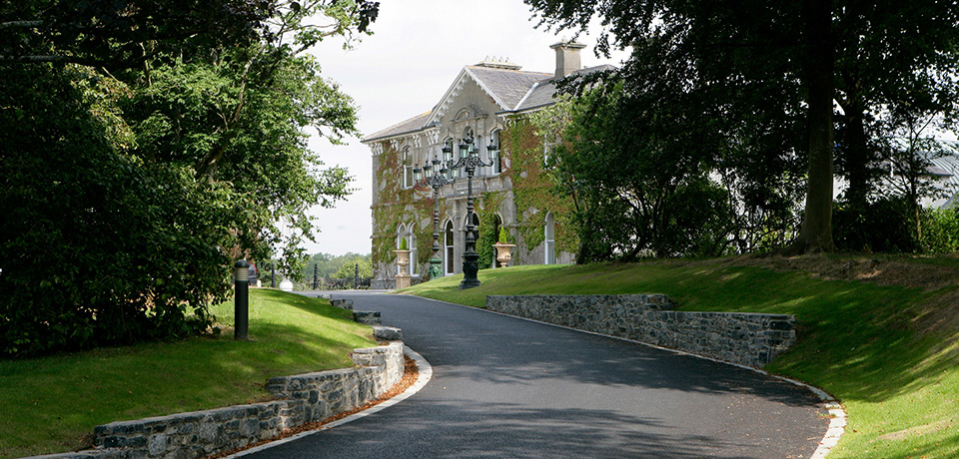
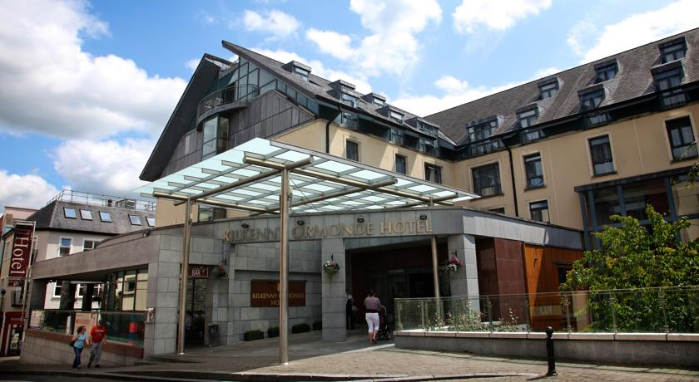

Hotel | Star Rating | Single Room | Double Room | Triple Room | Distance to/from The Hub (driving)
Lyrath Hotel | 5* | €100 - €125 | €150 - €200 |  | 2 min
Pembroke Hotel | 4* | €125 - €209 | €125 - €209 | €125 - €239 | 7 min
Springhill Court Hotel | 3* | €70 - €150 | €80 - €150 | €100 - €173 | 7 min
Hotel Kilkenny | 4* | €125 - €130 | €135 - €145 | €165 - €175 | 8 min
Newpark Hotel | 4* | €80 - €150 | €100 - €160 | €130 - €230 | 8 min
Club House Hotel | 3* | €65 - €80 | €125 - €140 | €135 - €145 | 8 min
Kilkenny Ormonde Hotel | 4* | €105 - €182 | €116 - €193 | €170 - €275 | 9 min
Kilkenny Inn Hotel | 3* | €85 - €100 | €125 - €135 | €135 - €145 | 10 min
The Lord Bagenal Inn | 4* | €70 - €85 | €95 - €130 | Not Available | 20 min
Abbeyleix Manor Hotel | 3* | €79 | €92 | €138 | 30 min
Talbot Hotel Carlow | 4* | €75 - €85 | €90 - €110 | €90 -€110 | 30 min
Seven Oaks Hotel | 4* | €85 | €130 | €185 | 30 min
Tower Hotel Waterford | 3* | €95 | €105 | €157 | 40 min
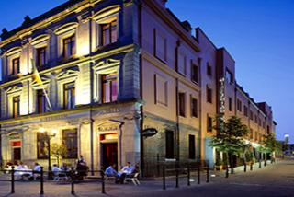

Individuals
For individuals we recommend minimum 2 nights stay. Individuals will be able to book their accommodation online through our booking system.
Groups
Groups of 5 people and more staying for minimum 3 nights will be advised to contact us directly so we can facilitate their requirements and offer the best rates available as each group will have unique and different requests.
Based on the room rates quoted, for groups staying in Kilkenny for minimum 3 nights, we should be able to offer group accommodation options, starting from €45 per person per night (shared, triple room).
Groups staying outside Kilkenny for minimum 3 nights, can book their triple rooms from €35 per night per person
Bus Transfers
All bus transfers from the airport will be on the website
website: http://www.karate2017ireland.com/
email : karate2017@keynotepco.ie
www.karateireland.org

Enjoy the Kilkenny Experience
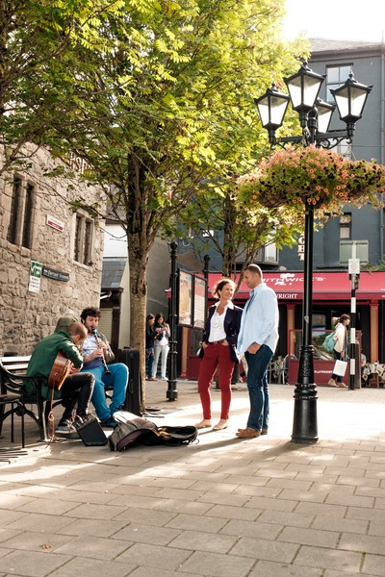

World Championships Kilkenny Ireland 2017
Categories

Children A (until 7 years)
Kata
(Shotokan, Goju Ryu, Wado Ryu, Shito Ryu, Shorin Ryu, Other Styles)
- White to Orange Belts (B) Green to Purple Belts (C) Brown to Black Belts

Kumite Shobu Nihon (All Styles)
- White to Green Belts (B) Purple to Black

Weights Female Male
Until 30 kg 30 kg
35 kg 35 kg
40 kg 40 kg
Over 40 kg 40 kg

Children B (8-9 years)
Kata
(Shotokan, Goju Ryu, Wado Ryu, Shito Ryu, Shorin Ryu, Other Styles)
- White to Orange Belts (B) Green to Purple Belts (C) Brown to Black Belts

Kumite Shobu Nihon (All Styles)
- White to Green Belts (B) Purple to Black

Weights Female Male
Until 35 kg 35 kg
40 kg 40 kg
45 kg 45 kg
Over 45 kg 45 kg

Children C (10-11 Years)

Kata
Shotokan, Goju Ryu, Wado Ryu, Shito Ryu, Shorin Ryu, Other Styles)
- White to Orange Belts (B) Green to Purple Belts (C) Brown to Black Belts

Kumite Shobu Nihon (All Styles)
- White to Orange Belts (B) Green to Purple (C) Brown to Black Belts

Weights Female Male
Until 37 kg 35 kg
42 kg 40 kg
47 kg 45 kg
Over 47 kg Until 50 kg
Over 50 kg

Young (12-13 years)

Kata
(Shotokan, Goju Ryu, Wado Ryu, Shito Ryu, Shorin Ryu, Other Styles)
(A)White to Blue (B) Purple to Black Belts

Kata Team
(All Styles, All Belts)

Kumite Shobu Nihon (All Styles, All Belts)
(A)White to Blue Belts (B) Purple to Black Belts

Weights Female Male
Until 45 kg Until 45 kg
53 kg 53 kg
Over 53 kg 60 kg
65 kg
Over 65 kg

Kumite Team Shobu Sanbon (All Styles, All Belts)
Kumite Team Rotation Shobu Sanbon (All Styles, All Belts)

Cadet A (14-15 years)

Kata
(Shotokan, Goju Ryu, Wado Ryu, Shito Ryu, Shorin Ryu, Other Styles)

Kumite Shobu Sanbon & Shobu Ippon (All Styles, All Belts)

Weights Female Male
Until 50 kg 50 kg
57 kg 55 kg
Over 57kg 63 kg
70 kg
Over 70 kg

Weights for Female & Male Ippon - Open Weight

Kumite Team Shobu Sanbon (All Styles, All Belts)
Kumite Team Shibu Ippon (All styles, All Belts)
Kumite Team Rotation Shobu Sanbon (All Styles, All Belts)
Kumte Team Rotation Shobu Ippon (All Styles, All Belts)

Cadet B (16-17 years)

Kata
(Shotokan, Goju Ryu, Wado Ryu, Shito Ryu, Shorin Ryu, Other Styles)

Kumite Shobu Sanbon & Shobu Ippon (All Styles, All Belts)

Weights Female Male
Until 53 kg 55 kg
60 kg 63 kg
Over 60 kg 70 kg
78 kg
Over 78kg

Weights for Female & Male Ippon - Open Weight
Kumite Team Shobu Sanbon (All Styles, All Belts)
Kumite Team Shibu Ippon (All styles, All Belts)
Kumite Team Rotation Shobu Sanbon (All Styles, All Belts)
Kumte Team Rotation Shobu Ippon (All Styles, All Belts)

Juniors (18-Under 21 years)

Kata

(Shotokan, Goju Ryu, Wado Ryu, Shito Ryu, Shorin Ryu, Other Styles)

Kumite Shobu Sanbon & Shobu Ippon (All Styles, All Belts)

Weights Female Male
Until 55 kg 62 kg
63 kg 68 kg
Over 63kg 74 kg
80 kg
Over 80 kg

Weights for Female & Male Ippon - Open Weight

Kumite Team Shobu Sanbon (All Styles, All Belts)
Kumite Team Shibu Ippon (All styles, All Belts)
Kumite Team Rotation Shobu Sanbon (All Styles, All Belts)
Kumte Team Rotation Shobu Ippon (All Styles, All Belts)

Seniors
Kata
(Shotokan, Goju Ryu, Wado Ryu, Shito Ryu, Shorin Ryu, Other Styles)

Kumite Shobu Sanbon (All Styles, All Belts)

Weights Female Male
Until 55 kg 62 kg
63 kg 68 kg
Over 63kg 74 kg
80 kg
Over 80 kg

Kumite Shobu Ippon (All Styles, All Belts)
Weights Female Male
Open Until 70 kg -
Over 70 Kg

Kumite Team Shobu Sanbon (All Styles, All Belts)
Kumite Team Shibu Ippon (All styles, All Belts)
Kumite Team Rotation Shobu Sanbon (All Styles, All Belts)
Kumte Team Rotation Shobu Ippon (All Styles, All Belts)

For Kata Team Competition this is all styles only, federations can only register 2 (Two) teams per category and is for 14yrs -35yrs (all together).

For All categories federations can register unlimited number of competitors per category for Kata and Individual Kumite and for Team Kumite Competition (from Young 12/13 to Seniors) federations can only register 2 (two) team per category (3+1). Kumite competitors can register in ‘Shobu Sanbon’ or ‘Shobu Ippon’ not both. Kata Competitors can register in one style only

Kumite competitors can register in ‘Shobu Sanbon’ or ‘Shobu Ippon’ not both. Kata Competitors can register in one style only

Veterans A (36 – 45 years) & Veterans B (46 years & over)

Kata
(Shotokan, Goju Ryu, Wado Ryu, Shito Ryu, Shorin Ryu, Other Styles)

Kata Team
(All Styles, All Belts)

Kumite Shobu Sanbon Male (All Styles, All Belts) Veterans A & B
Open Weights
Kumite Shobu Ippon Male (All Styles, All Belts) Veterans (Over 36 years)
Open Weight

Kumite Shobu Sanbon Female (All Styles, All Belts) Veterans (Over 36 years) Open Weight
Kumite Shobu Ippon Female (All Styles, All Belts) Veterans (Over 36 years) Open Weight
Kumite Team Shobu Sanbon (All Styles, All Belts)
Kumite Team Shibu Ippon (All styles, All Belts)
Kumite Team Rotation Shobu Sanbon (All Styles, All Belts)
Kumte Team Rotation Shobu Ippon (All Styles, All Belts)

For All categories In Veterans federations can enter unlimited number per category for Individual Kata & Kumite and for Team Kata & Team Kumite (3+1) Competition federations can register 2 teams per category. Kumite competitors can register in ‘Shobu Sanbon’ or ‘Shobu Ippon’ not both. Kata Competitors can register in one style only

All Seminar’s, Registration and Competition Events to be held in
The Hub, Cillin Hill, Kilkenny
THURSDAY 19th October 2017
09.00 to 18.00 Registrations for all competitors (passport and weight check)
09.00 to 16.00 Referees Seminar (presentation and testing, practical work). Mandatory for all referees and judges
16.00 to 18.00 Technical Seminars (Mandatory for all Coaches and Referees)

FRIDAY 20th October 2017
08.30 Up Competition for Children, Young & Veterans
16.00 All Team Events
19.00 to 20.00 Opening Ceremony (all competitors, presidents, officials, referees and judges)

SATURDAY 21st October 2017
08.30 Up Competition for Cadets, Juniors & Seniors

SUNDAY 22nd October 2017
08.30 Up All Finals Competitions for Young, Cadets, Juniors, Seniors & Veterans
20.00 Sayonara Party (Hotel to be decided) All Welcome
This is a draft scheduling to be confirmed
For registration for the event contact the International Karate Union

